Ewalt Volschenk

Week 1: Practical

Task 1: Screenshot of Subscription page
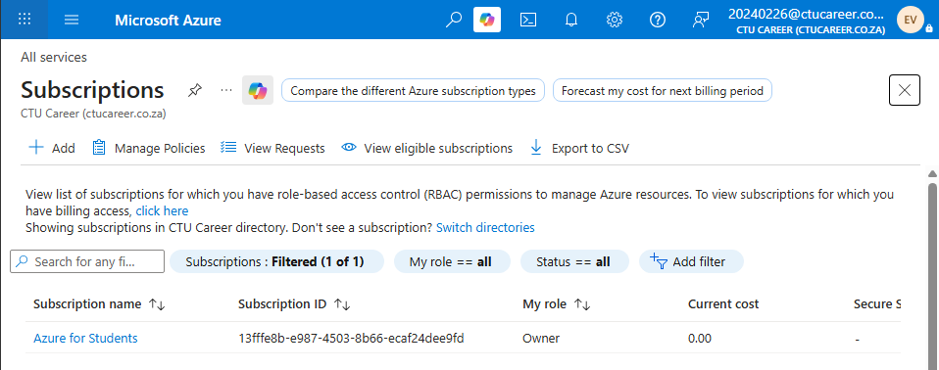
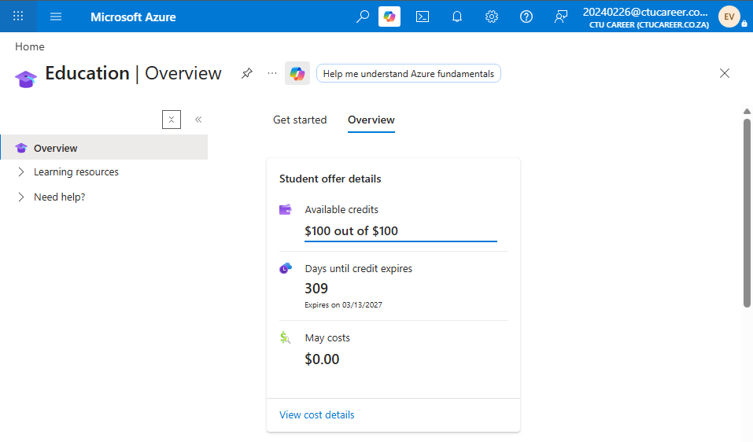

Task 2
1. Organisational Overview
CTU Training Solutions is a mid-to-large private higher education and IT training institution. Its primary purpose is delivering accredited technology and business qualifications to thousands of students annually.
2. Main IT Needs
Staff require reliable access to administrative systems, learning management platforms, email, and collaboration tools across all campuses. Students need on-demand access to study resources, virtual labs, assessments and cloud software such as Teams. Data management demands include secure storage of academic records and assessment data in compliance with the POPI Act. Applications such as Microsoft 365 and Campus Online must be available 24/7 with minimal downtime.
3. Why Azure Over On-Premises Infrastructure
Azure provides scalable, pay-as-you-go infrastructure that eliminates the capital expenditure of on-premises servers. As student enrolments fluctuate seasonally, Azure's elastic scaling ensures resources increase or decrease accordingly. Centralised cloud management reduces the IT burden across distributed campuses and improves disaster recovery capabilities.
4. Security and Compliance Requirements
CTU must comply with the Protection of Personal Information Act, which governs how student and staff data is collected, stored, and processed in South Africa. Azure's built-in compliance tools including role-based access control, Azure Active Directory and multi-factor authentication directly support these obligations. Additionally, regular security audits, data loss prevention policies, and Azure Defender must be implemented to safeguard sensitive academic and financial records.
5. Expected Number of Users
CTU serves an estimated 2000-3000 active students and approximately 500 staff members across 12 national campuses at any given time. The Azure environment must therefore be provisioned to support concurrent access by up to 3500 users, with capacity to scale during peak periods such as registration, examinations, and corporate training intakes.

Sources
Microsoft Learn, n.d. Microsoft SharePoint. [Online]
Available at: https://www.microsoft.com/en-za/microsoft-365/sharepoint/collaboration
[Accessed 28 April 2026].
Microsoft, n.d. Multifactor authentication in Microsoft Entra. [Online]
Available at: https://www.microsoft.com/en-za/security/business/identity-access/microsoft-entra-mfa-multi-factor-authentication
Popia.co.za, n.d. Protection of Personal Information Act (POPI Act). [Online]
Available at: https://popia.co.za/
[Accessed 8 May 2026].
ShareGate Team, 2026. On-premises SharePoint vs. SharePoint Online in 2026. [Online]
Available at: https://sharegate.com/blog/sharepoint-on-premises-vs-sharepoint-online
[Accessed 28 April 2026].

Declaration of Authenticity
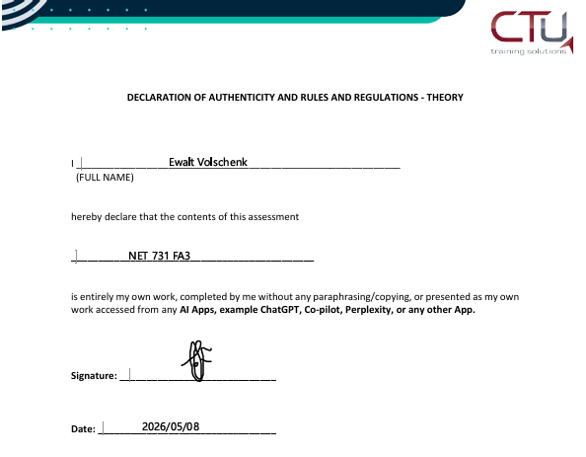

Task 3
Azure Service | Purpose / Why you need it | Week it is used
Resource Group | Groups all CTU Azure resources for simplified management | Week 1
Virtual Network (VNet) | Creates a private, isolated network for secure communication between Azure resources | Week 2
Virtual Machine (VM – B1s) | Hosts CTU's server workloads | Week 3
Microsoft Entra ID | Manages identity and access for all staff and student accounts | Week 4
Network Security Group (NSG) | Controls inbound and outbound traffic to Azure resources | Week 4
Azure Storage Account | Provides scalable cloud storage | Week 5
Microsoft Defender for Cloud | Monitors security posture, detects threats, and provides compliance recommendations | Week 6
Azure Monitor | Collects performance telemetry and sends alerts for system anomalies | Week 7
Azure Cost Management | Tracks and optimises cloud spending | Week 8

Task 4

